Welcome and welcome to the quiz #FervedoiroNaPraia
To begin, let's name our team (its members must remember the name of their team)
We take note of the time of participation
In this game you will be presented with a battery of questions and challenges related to different subjects
In the case of 3rd ESO students, all the activities of the day are considered as course evaluations for the different subjects that are proposed
The teams that manage to correctly overcome more challenges will also be awarded with a gift that will be given to them in the coming days

Cotext file for teachers:
• Name our team:
• Time of participation:
• Correctly solved challenges or answers:
• Indicate what was the last question or challenge (just put the subject and number of the question)
Team Name
Time of participation
Correctly solved challenges or answers
Last question or challenge solved
Team Name
Time of participation
Correctly solved challenges or answers
Last question or challenge solved
Team Name
Time of participation
Correctly solved challenges or answers
Last question or challenge solved
Team Name
Time of participation
Correctly solved challenges or answers
Last question or challenge solved

GEOGRAPHY AND HISTORY
1. How many parishes make up the municipality of Rianxo
Correct answer: 6
O Araño, Asados, Isorna, Leiro, Rianxo and Taragona.
2. How many inhabitants are there in Rianxo. Choose the correct answer:
Answer: Source (IGE)
A. 18,950 inhabitants (Boiro)
B. 8,355 inhabitants (Register)
C. 98,687 inhabitants (Santiago)
D. 10,864 inhabitants (Rianxo)
3. Rianxo is a fishing village on the Ría de Arousa. According to the IGE, its surface area is 58.79 km² and it has a population of 10,864 inhabitants. What is its population density??
Answer: 184.79 inhabitants/Km͔² Source (IGE)
4. Which of these economic activities is the one that employs the most working people in Rianxo?
Answer Source (IGE)
A. Agriculture and fishing: 11.8%
B. Construction: 8.4%
C. Industry: 18.5%
D. Services: 62.8%
5. What are the 4 largest islands in the Ría de Arousa?
Answer: Arousa, Sálvora, A Toxa and Cortegada
6. Which Rianjeiro surname and typical of the Rías Baixas legend has it that it was the result of the relationship between a mermaid and a "noble" knight
Answer: Marine
7. Which of these 4 elements is not representative of the cultural heritage of Rianxo:
answer
A. Casco de Leiro
B. Castle of the Moon
C. Castro de Neixón
D. Dolmen of Dombate
8. Which of these elements of the cultural heritage of Rianxo is more important to know when this territory was inhabited by human beings?
answer
A. Petroglyph of the Owls
B. Castle of the Moon
C. Castro das Cercas and Castro de Quintáns
D. Martelo Palace
9. The written documentation about Castelo da Lua indicates that it was erected, probably in the 13th century, by Paio Gómez Charino, and demolished by the Irmandiños around 1465 and rebuilt again by Suero Gómez de Soutomaior, again demolished by the royal governor Fernando Acuña around 1480. Then, in what century was the Castle demolished?
Answer: s. XV
10. Between 1937 and 1939 during the Spanish Civil War Rianxo was subject to Franco's repression and there was even a concentration camp in the town. Where was the concentration camp?
answer
Castle Street
Plaza de la Fonte
Rua do Portiño
Rua de Paio Gómez Chariño

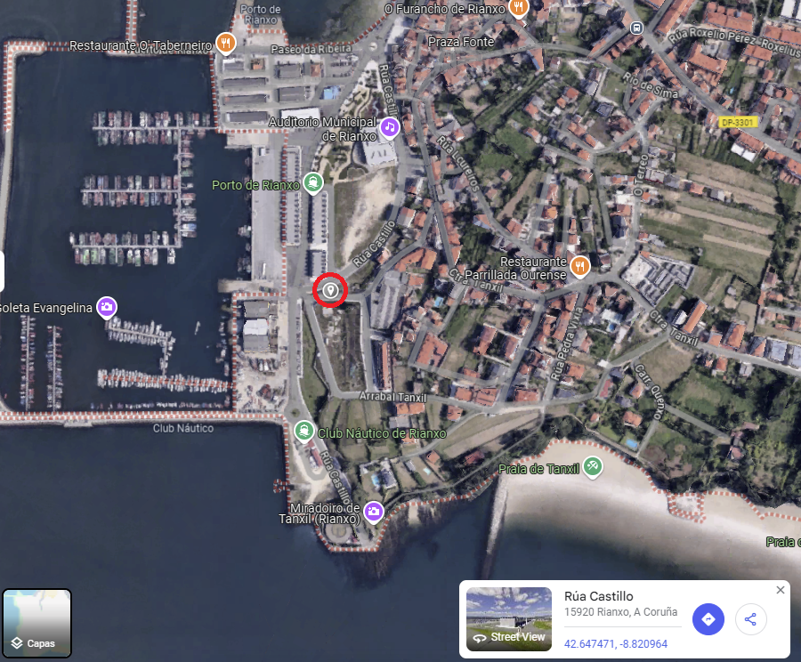

GALICIAN LANGUAGE
Language and literature questionnaire

1. Which writer has a house museum in Rianxo?
Answer Manuel Antonio
2. Which Rianjeiro writer is considered the most important figure in Galician culture of the 20th century?
Answer Castelao
3. Which Rianjeiro writer used the pseudonym Félix Muriel?
Answer Rafael Dieste
4. Which Rianxo parish has the name of a small farmland?
Answer Leiro
5. What does the toponym Rianxo mean?
answer
a) Place where the estuary ends
b) Wide river to navigate
c) Angular river with many curves and corners
d) Mr. Anxo's river, which ruled the town
6. Who are Jesus Frieiro Dourado and Angel Romero Loxo?
Answer The authors of Rianxeira
7. In 2023 the Spanish Patent and Trademark Office approved the registration of the quality mark of a typical Rianxo fish. what is it
Answer A joke.
8. What is the name of the traditional fishing technique used to catch Rianxo's xouba (sardine)?
Answer The way.
9. With the music of the Rianxeira you have to invent two stanzas of a song about the care of beaches and oceans.
10. You have to draw the silhouette of Rianxo council in the sand and place the signs #EUBeachCleanup and #EULimpoapraia underneath

Questionnaire about beaches of Rianxo

1. How many beaches does Rianxo have?
Answer 8
2. What is the name of the beaches of Rianxo?
Answer The Tower, The Pazo, Rinlo (Chestnuts), Quenxo, Tanxil, The Trunk, The Porrón, The Cunchas.
3. Of all the beaches in Rianxo, which one is further north?
Answer The Tower.
4. What is the biggest beach in Rianxo and in which parish is it?
Answer A from the Tower in the parish of Taragoña.Cuestionario lingua e literatura

MATHEMATICS
1. Let's measure the surface of the beach, assuming that one step is approximately one meter:
a) how long is this beach?
b) what will be its surface area? You must explain in detail how you perform these calculations.
2. If the sand has a depth of 2 meters, with the measurement made in the previous section, how much will the sand on this beach weigh, assuming that 1 m³ is 750 kg.
3. Knowing that a person generates 1.11 kg of garbage a day. How long would it take you to fill this sandpit with your scraps?
4. If it costs 4 cents to manage a kilo of waste, how much does it cost to manage the waste you generate in a year?
5. Assuming that a person who is going to spend all day on the beach occupies 2 m²,
a) how many people would catch in this arena
b) with the data obtained in the previous sections, what amount of garbage would be generated at the end of the day on this beach.
c) how much its management would cost

PHYSICS AND CHEMISTRY
1. The formula of the oxygen we breathe from the atmosphere is:
answer
A.O.
B.O2,
C. O3
2. Which value is greater? oxygen molecules in your lungs right now or grains of sand from all the beaches in the world?
Answer: Oxygen from the lungs
Explanation: Even if you have a volume of oxygen in your lungs right now that is slightly less than 1 liter, the amount of molecules in that volume is huge, even bigger than grains of sand on all the beaches in the world
3. The formula H2O is: water, carbon dioxide, glucose
Answer:
A. water
B. carbon dioxide
C. glucose
4. Sea and ocean water is salty, how can you get the salt to use in cooking?
Answer:
D. Filtering
E. evaporating
F. with a magnet
5. Water can be solid, liquid or gas. The solid is denser than the liquid.
Answer: True or false. Explanation is less dense that's why ice floats.
6. The greenhouse effect is bad for the Earth, true or false.
Answer: True or false Explanation, it is a beneficial effect to keep the Earth's temperature at stable values ​​and allow life as we know it. The bad thing is the increase in this effect that causes the increase in the earth's temperature.
7. Temperature can affect chemical reactions, true or false.
Answer: true or false. Explanation reactions occur faster if the temperature increases, that's why we use refrigerators to preserve food
8. The solubility in water of a substance is affected by temperature, true or false.
Answer: true or false. Explanation, think of water and sugar, if you have a lot of sugar you can dissolve it by heating it, there are other processes that benefit if the temperature drops, that is to say there is more dissolved solute at a lower temperature.
9. Now, if the temperature of the sea water varies, processes such as the dissolution of oxygen in the water can be affected: really
answer
A. does not influence because there will be more oxygen in the water,
B. will influence because it will decrease the dissolved oxygen in the water.
Explanation: The solubility of oxygen in water decreases with increasing temperature.
10. Seas and oceans can dissolve CO2 in the atmosphere, thus reducing the presence of this gas in the atmosphere and mitigating the effects of climate change. so,
answer
A. this is beneficial for climate change since greater presence of CO2 in water does not influence biochemical processes
B. this has the consequence that the seas and oceans become more acidic and therefore affect the biochemical processes.
Biology: Marine ecosystem and coasts of Rianxo
1. How do you think coastal erosion would affect the populations of marine organisms on the beaches of Rianxo?
a) It would increase the diversity of species.
b) It would reduce the habitable space for many organisms. (Correct)
c) It would not affect marine species.
d) It would increase the availability of food.
2. The proliferation of algae in Galician estuaries may be related to climate change. What effect could this phenomenon have on marine food chains?
a) The algae would be eliminated by other species.
b) The excess of algae could reduce the oxygen available in the water, negatively affecting the fish. (Correct)
c) The increase in algae would benefit all species.
d) It would not have any significant impact.
3. Why do you think plastic pollution on beaches not only affects marine organisms, but also human health?
a) Because plastics only affect terrestrial fauna.
b) Because plastics can enter the food chain through the fish we eat. (Correct)
c) Because plastics are harmless to humans.
d) Because plastics disintegrate very quickly.
4. If the water temperature in estuaries increases due to climate change, what could happen to native fish species?
a) They would easily adapt to the new conditions.
b) Some fish could migrate to colder waters. (Correct)
c) Fish species would increase rapidly.
d) There would be no changes in the fish population.
5. In your opinion, how would the loss of biodiversity in the Rianxo coastal ecosystem affect the local fishing sector?
a) It would have no impact, because there are many resources in the ocean.
b) It would reduce the availability of commercial species. (Correct)
c) It would increase the amount of fish available.
d) It would encourage the growth of mollusk populations.
6. What measures could the local community take to protect Rianxo's marine ecosystems from future damage?
a) Limit people's access to the beaches.
b) Promote sustainable fishing practices and reduce the use of plastics. (Correct)
c) Evacuate the populations close to the sea.
d) Eliminate environmental protection areas.
7. Why is it important to analyze water quality and the presence of pollutants in Galician estuaries?
a) To improve recreational fishing.
b) To detect possible risks to the health of marine organisms and people. (Correct)
c) To determine if the water is potable.
d) To increase the salinity of the water.
8. The introduction of invasive species into estuaries can be a serious problem. What impact do you think it would have on the Rianxo ecosystem?
a) Invasive species would help control local populations.
b) Invasive species could displace native species (Correct)
c) They would not have any significant impact.
d) They would increase local biodiversity.
9. How could sea level rise affect us in the long term on the Rianxo coast?
a) It could reduce the areas of natural habitat in coastal areas. (Correct)
b) It would favor the creation of new beaches.
c) It would increase the possibilities of fishing.
d) It would not have effects on the Galician coast.
10. Red tides are occasional phenomena in Galician estuaries. Do you think they are related to human impact? Why?
a) No, they are completely natural phenomena.
b) Yes, pollution and excess nutrients can contribute to their appearance. (Correct)
c) No, they are caused by ocean currents.
d) Yes, but only because of overfishing.

